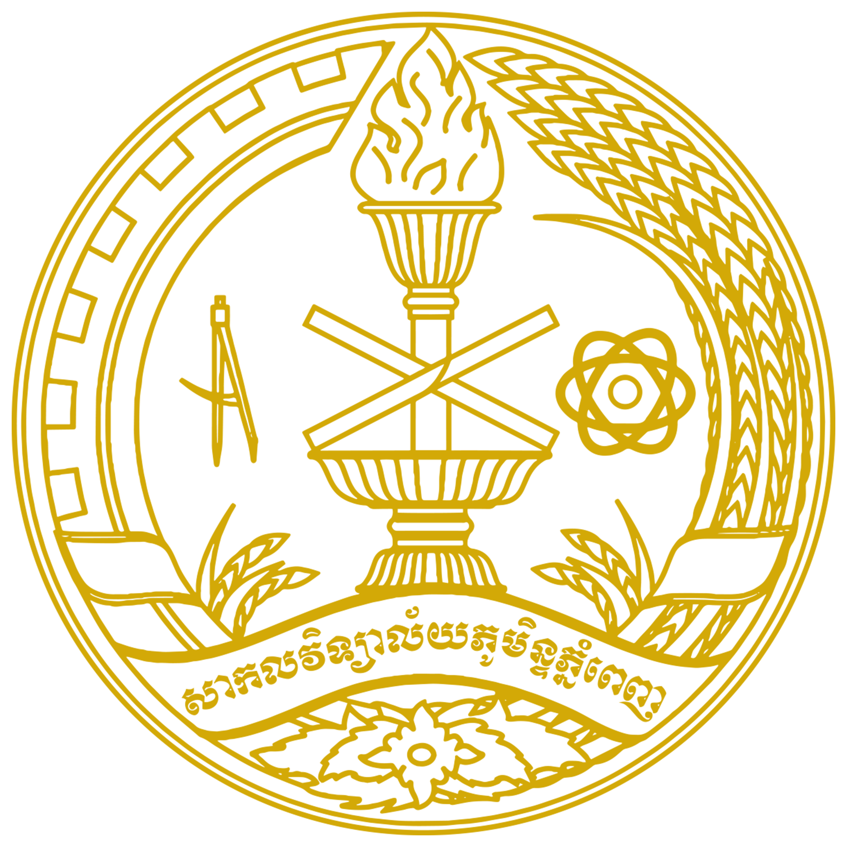
ROYAL UNIVERSITY OF PHNOM PENH

Master of International Sustainable Tourism
Management and Excellence

4*6
Personal Information
Family Name: ............................................First Name........................................
Sex Male Female Others…………….
Date of birth: (DD/MM/YY) .............................................................................
Place of birth: ...............................................................................................................................
Identity card/passport number: .................................................. Expiry date: .............................
Marital status: Single Married Other
Current address: Nº .................Street ............... Sangkat/Commune...........................................
Khan/District: ........................................... City/Province: .........................................................
Tel: ....................................................... Email: ..........................................................................
Bachelor’s degree in …………………………………………………………………………….

Family Information
Father Name:……………………………………………… Date of birth:……………………..
Place of birth:……………………………………………............................................................ Job:……………………………..……………………………………………………………….
Mother Name:……………………………………………… Date of birth:………………….…
Place of birth:……………………………………………………………………………….…... Job:……………………………………………………………………………....………………

Academic Information
List in chronological order colleges/universities you have attended.
Name of University | Attended from/to |  | Degrees Obtained | Main course of study

Work Experience
Present post (Last post if not currently employed)
Position: ...............................................................................................................................
Institution: ...............................................................................................................................
Duties: ...............................................................................................................................
...............................................................................................................................
...............................................................................................................................
...............................................................................................................................
...............................................................................................................................

Name and address of the employer
Name: ...............................................................................................................................
Address # ..................... Street # .................Sangkat/commune .........................................
Khan/District ................................................... City/Province: ............................
Tel:. ........................................Fax:............................. Email:..............................

Funding Source
Self Employer Other (Specify………………..………………..)

Declaration
I declare that the information provided in this application form is true to the best of my knowledge.
Phnom Penh, Date: ……………………………
Applicant’s name and signature

ROYAL UNIVERSITY OF PHNOM PENH

RECIEPT
Master of International Sustainable Tourism
Management and Excellence

4*6
Personal Information
Family Name: ............................................First Name........................................
Sex Male Female Others…………….
Date of birth: (DD/MM/YY) .............................................................................
Place of birth: ...............................................................................................................................
Identity card/passport number: .................................................. Expiry date: .............................
Marital status: Single Married Other
Bachelor’s degree in …………………………………………………………………………….
Current Occupation: …………………………………………………………………………….
Mother Name: ………………………………. Father Name: ……………………………
Candidate from (institution): ……………………………………………………………………
Date of exam: ……………………………….. Exam Center: ……………………………
Phnom Penh, Date: ……………………. Phnom Penh, Date:. …………..…………
C/O Management Team Applicant’s name and signature

-----------------------------------------------------------------------------------------------------------------

ROYAL UNIVERSITY OF PHNOM PENH

RECIEPT
Master of International Sustainable Tourism
Management and Excellence

4*6
Personal Information
Family Name: ............................................First Name........................................
Sex Male Female Others…………….
Date of birth: (DD/MM/YY) .............................................................................
Place of birth: ...............................................................................................................................
Identity card/passport number: .................................................. Expiry date: .............................
Marital status: Single Married Other
Bachelor’s degree in …………………………………………………………………………….
Current Occupation: …………………………………………………………………………….
Mother Name: ………………………………. Father Name: ……………………………
Candidate from (institution): ……………………………………………………………………
Date of exam: ……………………………….. Exam Center: ……………………………
Phnom Penh, Date: ……………………. Phnom Penh, Date:. …………..…………
C/O Management Team Applicant’s name and signature

